# **Section -1 & Section -2:**

1. **For the given periodic signals with the period T = 3, compute the Fourier coefficients and then reconstruct the original signal.**

For each of the signals, plot the following:

* The original and reconstructed signal on the same plot
* The Fourier coefficients; both the real and imaginary components vs the theoretical values.

$x\left(t\right)=t^{2} , \left|t\right|<1$

$x\left(t\right)=1-\frac{\left|t\right|}{3} , \left|t\right|<1$

$x\left(t\right)=\cos\left(πt\right) , \left|t\right|<1$

1. **For the three signals, demonstrate the convergence of the reconstructed signal with respect to the original signal**.



function AK = FourierCoeff(signal, time, TimePeriod, K)

AK = zeros(size(K));

W = (2 * pi) / TimePeriod;

for ik = 1:length(K)

y = signal .* exp(-i*K(ik)*W*time);

AK(ik) = Integrate(y, time)/TimePeriod;

end

end



function signal = Converge(AK, K, TimePeriod, time)

W = (2*pi) / TimePeriod;

signal = zeros(size(time));

for ik = 1:length(K)

y = AK(ik) * (exp(1i*K(ik)*W*time));

signal = signal + y;

end

end

**MATLAB CODE**



% Section 1

% Q.1 Fourier Coefficients of x(t) = t^2

t = -1.5:0.01:1.5;

x = zeros(size(t));

N = 100;

x(t<=1 & t >= -1) = t(t<=1 & t >= -1).^2;

t2 = -3:0.01:5;

ConvergeError = zeros(1,N+1);

figure;

for ix = 0:1:N;

clf;

K = -ix:ix;

AK = FourierCoeff(x, t, 3, K);

plot(t,x,'k','LineWidth',2); hold on;

y = Converge(AK, K, 3, t2);

ConvergeError(ix+1) = sum((Converge(AK,K,3,t)-x).^2);

plot(t2,y,'r');

title('Reconstructed Signal'); title(['K = -',int2str(ix),' to ',int2str(ix)]); xlabel('time'); ylabel('x(t)'); grid on; axis equal;

pause(0.1);

end

figure; stem(0:N,ConvergeError);

title('Convergence'); ylabel('Error'); xlabel('K');

figure; stem(K, real(AK),'r');

hold on;

stem(K, imag(AK),'b');

title('Fourier Coefficients');

xlabel('K');

ylabel('Ak');

grid on;

legend('Real part of Ak', 'Imaginary part of Ak');

AK2 = 1/3*(2*sin(W*K)./(W*K)) + 1/3*(4*cos(W*K)./(W.^2*K.^2)) - 4/3*(sin(W*K)./(W.^3*K.^3));

figure;

stem(K,real(AK2))

hold on;

stem(K,imag(AK2))

hold on;

stem(0, 2/9);

title('Theoretical Fourier Coefficients');

legend('Real AK Theoretical', 'Imaginary AK Theoritical', 'A0 Theoretical');

ylabel('Theoretical AK'); xlabel('K');

**OUTPUT**



 

**THEORETICAL CALCULATIONS**

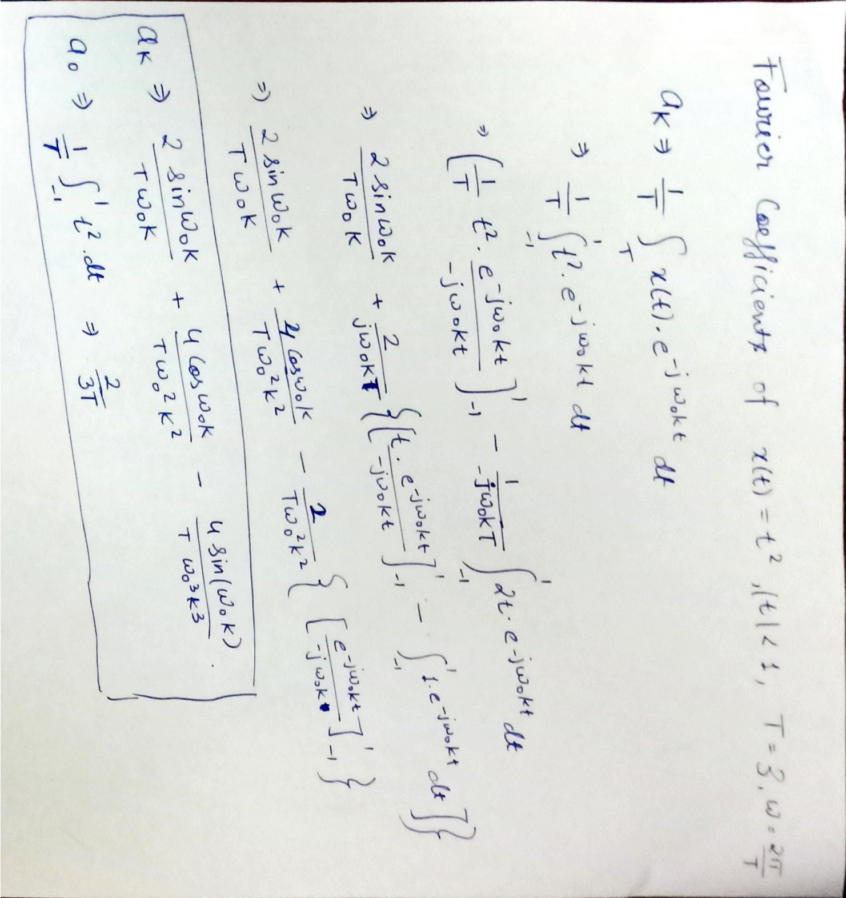

**MATLAB CODE**



% Section 1

% Q.2 Fourier Coefficients of x(t) = 1- |t|/3

t = -1.5:0.01:1.5;

x = zeros(size(t));

N = 100; W = 2*pi/3;

x(t<=1 & t >= -1) = 1- abs(t(t<=1 & t >= -1)/3);

t2 = -3:0.01:5;

ConvergeError = zeros(1,N+1);

figure;

for ix = 0:1:N;

K = -ix:ix;

AK = FourierCoeff(x, t, 3, K);

y = Converge(AK, K, 3, t2);

ConvergeError(ix+1) = sum((Converge(AK,K,3,t)-x).^2);

end

plot(t,x,'k','LineWidth',2);

hold on;

plot(t2,y,'r');

title('Reconstructed Signal'); title(['K = -',int2str(ix),' to ',int2str(ix)]);

xlabel('time'); ylabel('x(t)'); grid on; axis equal;

figure;

stem(0:N,ConvergeError);

title('Convergence'); ylabel('Error'); xlabel('K'); figure;

stem(K, real(AK),'r');

hold on;

stem(K, imag(AK),'b');

title('Fourier Coefficients');

l('K');

ylabel('Ak');

grid on;

legend('Real part of Ak', 'Imaginary part of Ak');

AK2 = 2/9*(2*sin(W*K)./(W*K) - cos(W*K)./(W.^2*K.^2) + 1./(W.^2*K.^2));

figure;

stem(K,real(AK2))

hold on;

stem(K,imag(AK2))

hold on;

stem(0, 5/9);

title('Theoretical Fourier Coefficients');

legend('Real AK Theoretical', 'Imaginary AK Theoritical', 'A0 Theoretical');

ylabel('Theoretical AK'); xlabel('K')

**OUTPUT**



**THEORETICAL CALCULATIONS** 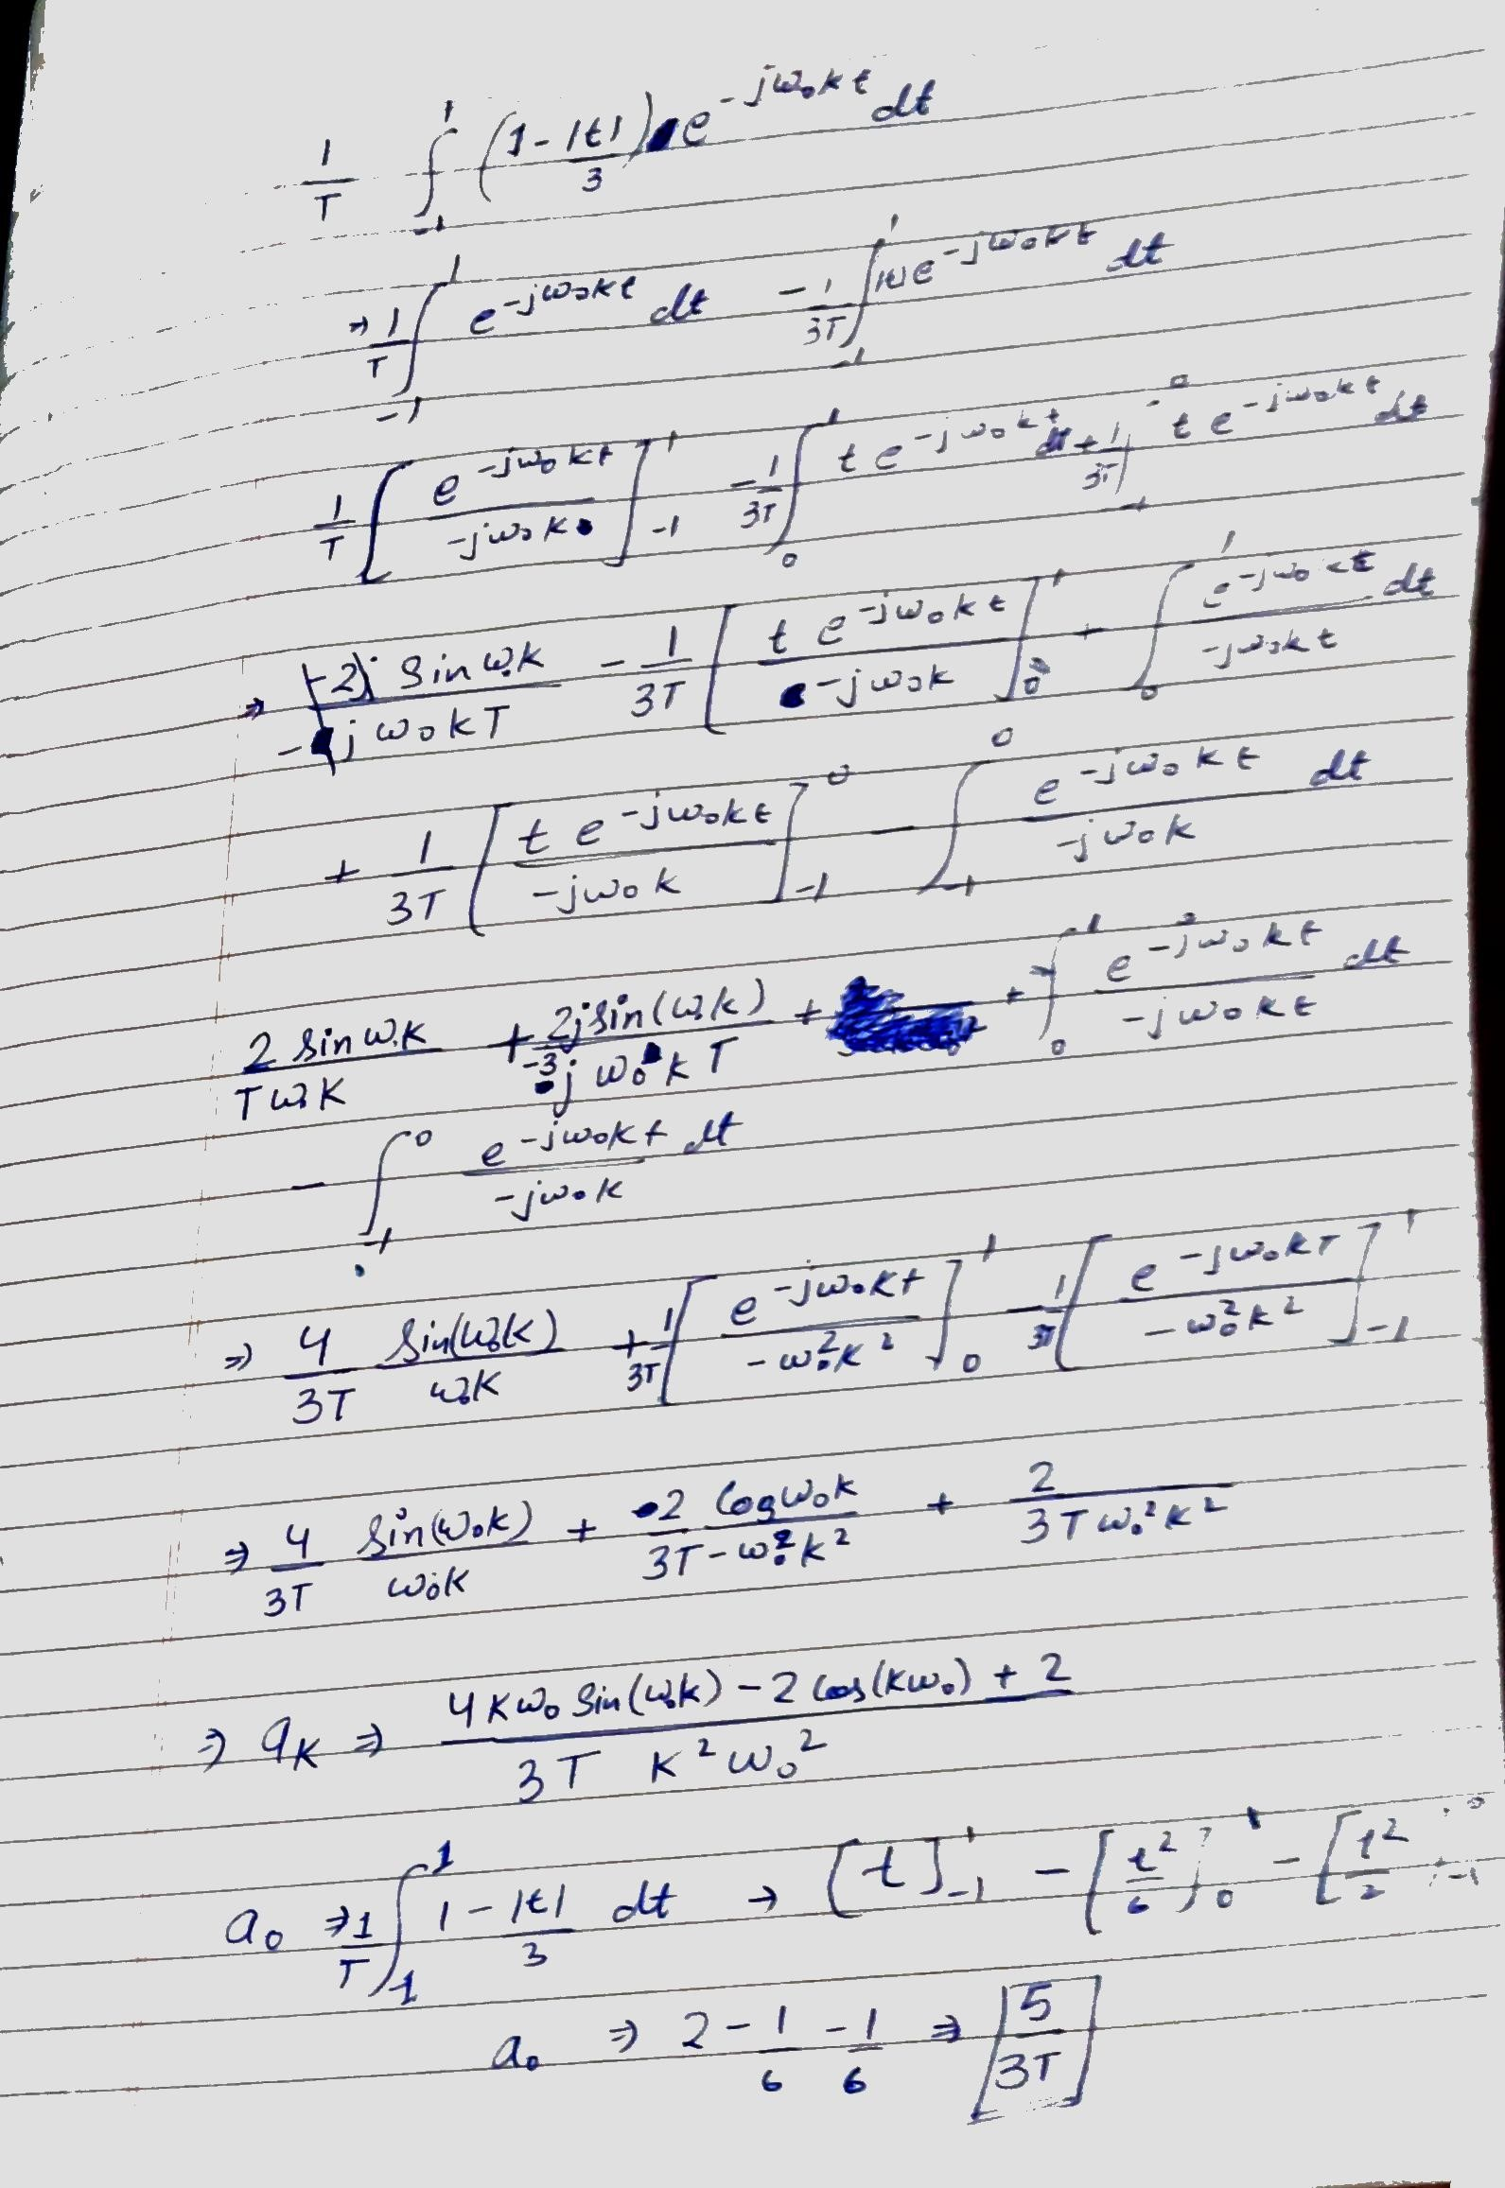

**MATLAB CODE**



% Section 1

% Q.3 Fourier Coefficients of x(t) = cos(pi*t)

t = -1.5:0.01:1.5;

x = zeros(size(t));

N = 100;

x(t<=1 & t >= -1) = cos(pi .* t(t<=1 & t >= -1));

t2 = -3:0.01:5;

ConvergeError = zeros(1,N+1);

figure;

for ix = 0:1:N;

clf;

K = -ix:ix;

AK = FourierCoeff(x, t, 3, K);

plot(t,x,'k','LineWidth',2);

hold on;

y = Converge(AK, K, 3, t2);

ConvergeError(ix+1) = sum((Converge(AK,K,3,t)-x).^2);

plot(t2,y,'r');

title('Reconstructed Signal'); title(['K = -',int2str(ix),' to ',int2str(ix)]);

xlabel('time'); ylabel('x(t)'); grid on; axis equal;

pause(0.1);

end

figure;

stem(0:N,ConvergeError);

title('Convergence'); ylabel('Error'); xlabel('K'); figure;

stem(K, real(AK),'r');

hold on;

stem(K, imag(AK),'b');

title('Fourier Coefficients'); xlabel('K'); ylabel('Ak');

grid on;

legend('Real part of Ak', 'Imaginary part of Ak');

AK2 = 1/3*(-2*W*K.*sin(W*K)./(W.^2*k.^2 - pi^2));

figure;

stem(K,real(AK2))

hold on;

stem(K,imag(AK2))

hold on;

stem(0, 0);

title('Theoretical Fourier Coefficients');

legend('Real AK Theoretical', 'Imaginary AK Theoritical', 'A0 Theoretical');

ylabel('Theoretical AK'); xlabel('K');

**OUTPUT**



**THEORETICAL CALCULATIONS**

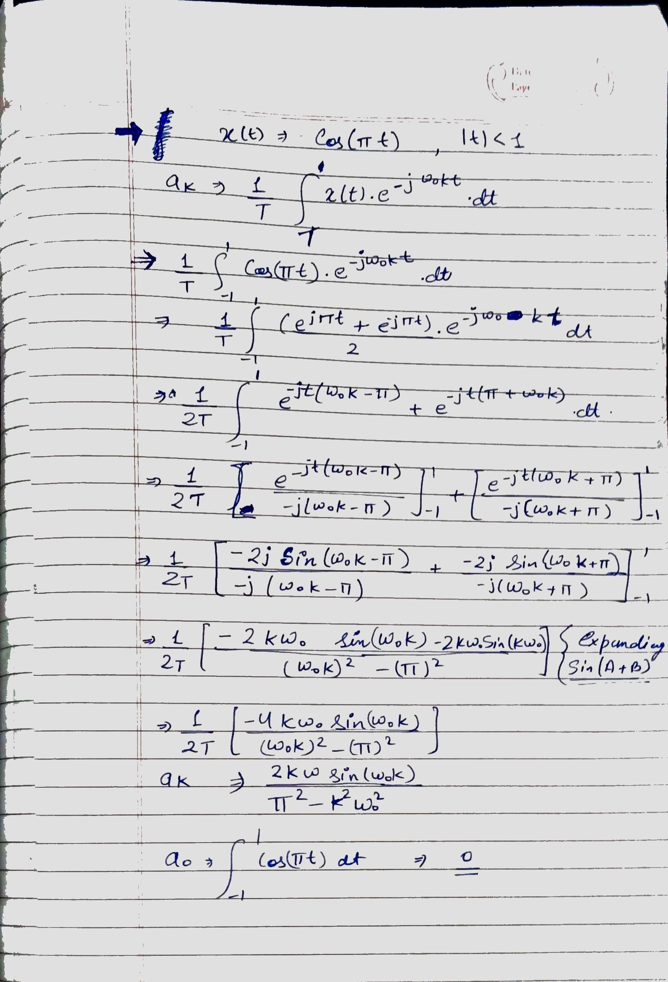

# **Section -3:**

**For the given aperiodic signals, compute the Fourier transform and then the inverse Fourier Transform.**

For each of the signals, plot the following:

* The original and reconstructed signal on the same plot
* The Fourier transform both the real and imaginary components vs the theoretical values.

$x\left(t\right)=t^{3} , \left|t\right|<1$

$x\left(t\right)=1-\frac{\left|t\right|}{2}, \left|t\right|<1$

$x\left(t\right)=sinc\left(t\right), \left|t\right|<2π$

**MATLAB** **CODE**



function FT = FourierTransform(signal, time, W)

iw = 1;

FT = zeros(size(W));

for w = W

FT(iw) = Integrate(signal.*exp(-1i*w*time), time);

iw = iw + 1;

end

end



function output = InvFourierTransform(signal, W, time)

output = zeros(size(time));

it = 0;

for t = time

it = it + 1;

output(it) = Integrate(signal.*exp(1i*t*W), W);

end

output = output/(2*pi);

end

**MATLAB CODE**



% Section 3

% Q.1 Fourier Transform x(t) = t^3, |t| < 1

t = -1:0.01:1;

x = t.^3;

figure; subplot(311);

plot(t,x);

title('Signal x(t) = t^3 , |t| < 1');

xlabel('time'); ylabel('x(t)'); grid;

W = -20*pi:pi/50:20*pi;

X = FourierTransform(x,t,W);

subplot(312);

plot(W, real(X), 'b');

hold on;

plot(W, imag(X), 'g');

title('Fourier Transform of x(t)');

xlabel('W'); ylabel('X(W)'); grid; legend('Real','Imaginary');

x_t = InvFourierTransform(X,W,t);

subplot(313);

plot(t,x_t);

title('Inverse Fourier Transform of X(W)');

xlabel('time'); ylabel('x(t)'); grid;

% Q.2 Fourier Transform x(t) = 1 - |t|/2, |t| < 1

t = -1:0.01:1;

x = 1 - abs(t)/2;

figure; subplot(311);

plot(t,x);

title('Signal x(t) = 1 - |t|/2 , |t| < 1');

xlabel('time'); ylabel('x(t)'); grid;

W = -20*pi:pi/50:20*pi;

X = FourierTransform(x,t,W);

subplot(312);

plot(W, real(X), 'b');

hold on;

plot(W, imag(X), 'g');

title('Fourier Transform of x(t)');

xlabel('W'); ylabel('X(W)'); grid; legend('Real','Imaginary');

x_t = InvFourierTransform(X,W,t);

subplot(313);

plot(t,x_t);

title('Inverse Fourier Transform of X(W)');

xlabel('time'); ylabel('x(t)'); grid;

% Q.3 Fourier Transform x(t) = sinc(t), |t| < 2*pi

t = -2*pi:0.01:2*pi;

x = sinc(t);

figure; subplot(311);

plot(t,x);

title('Signal x(t) = sinc(t), |t| < 1');

xlabel('time'); ylabel('x(t)'); grid;

W = -20*pi:pi/50:20*pi;

X = FourierTransform(x,t,W);

subplot(312);

plot(W, real(X), 'b');

hold on;

plot(W, imag(X), 'g');

title('Fourier Transform of x(t)');

xlabel('W'); ylabel('X(W)'); grid; legend('Real','Imaginary');

x_t = InvFourierTransform(X,W,t);

subplot(313);

plot(t,x_t);

title('Inverse Fourier Transform of X(W)');

xlabel('time'); ylabel('x(t)'); grid;

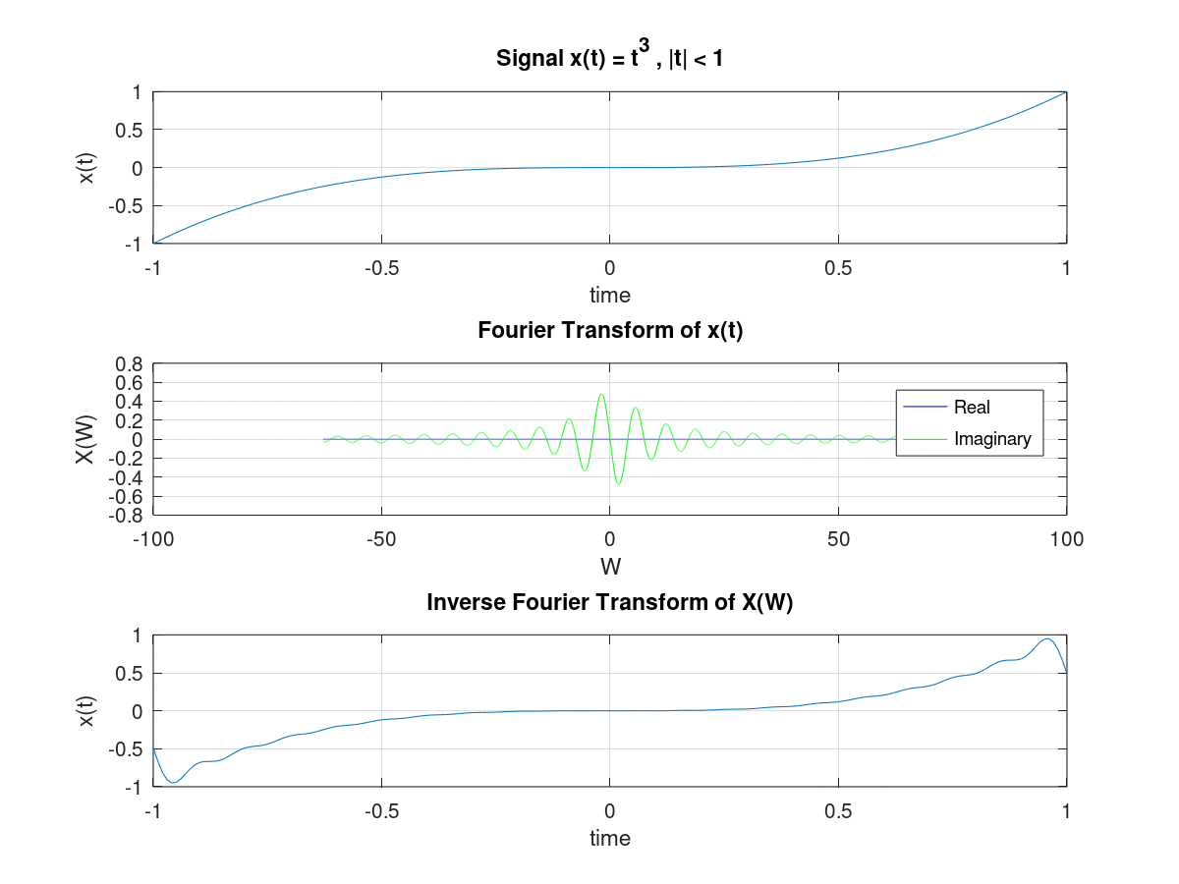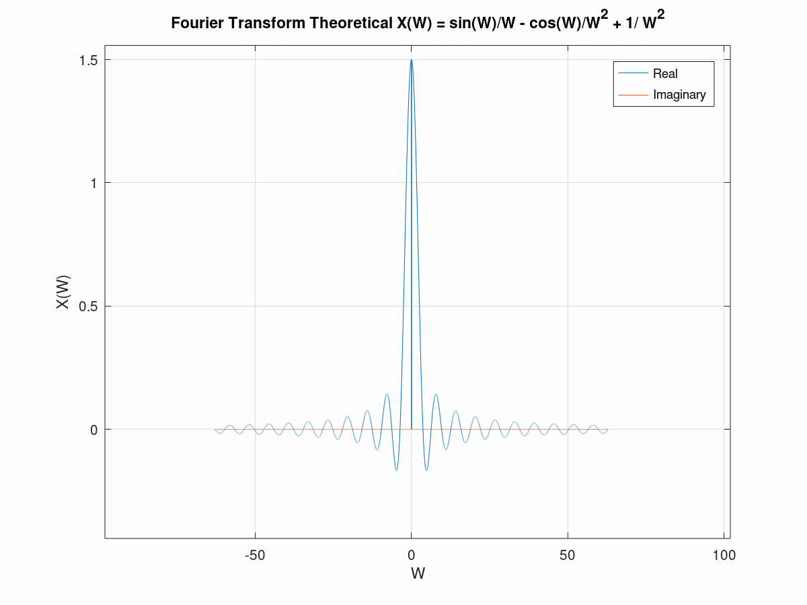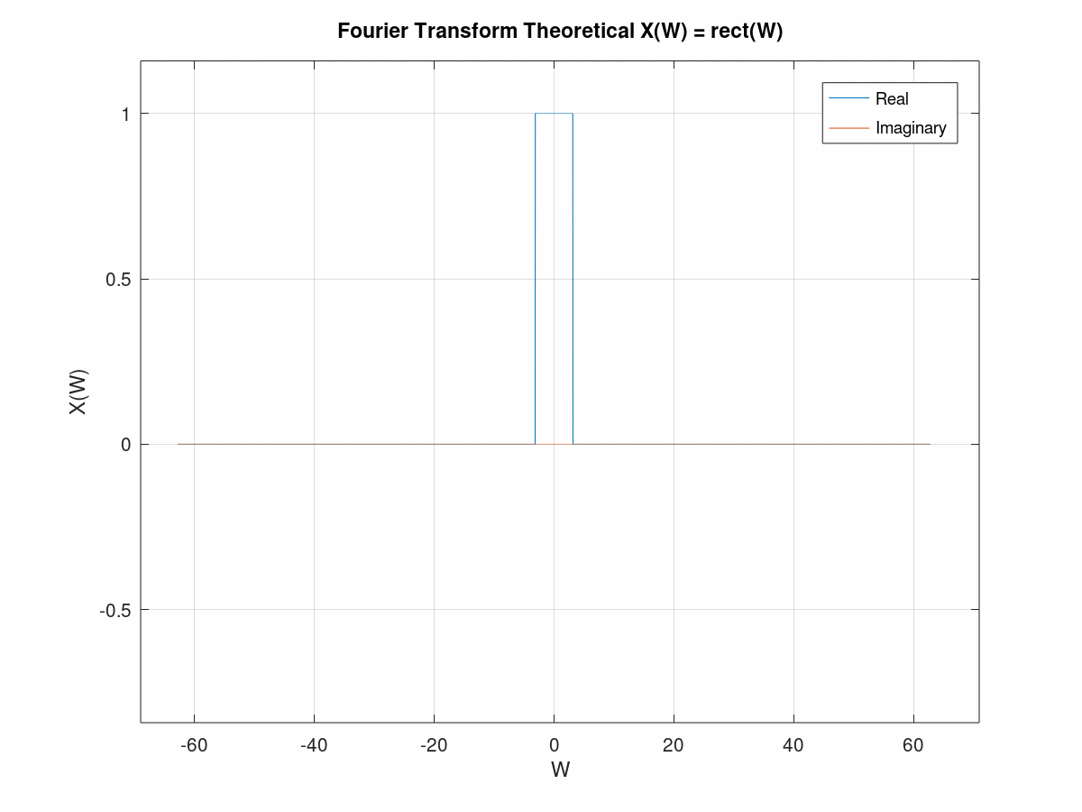

**THEORETICAL CALCULATIONS 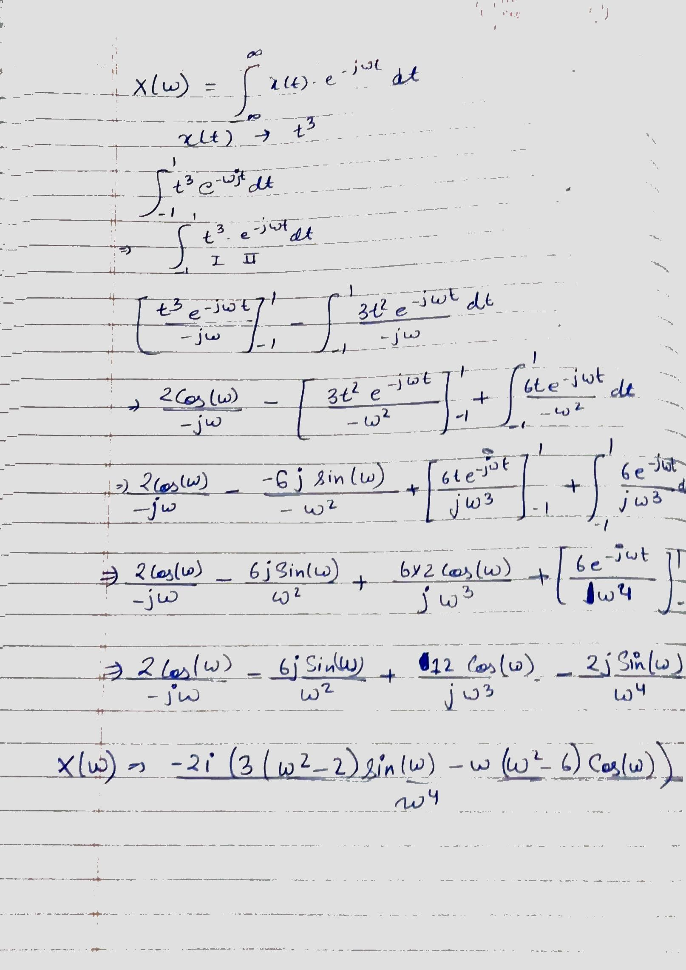 THEORETICAL CALCULATIONS** 